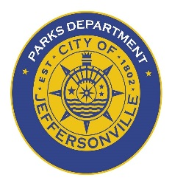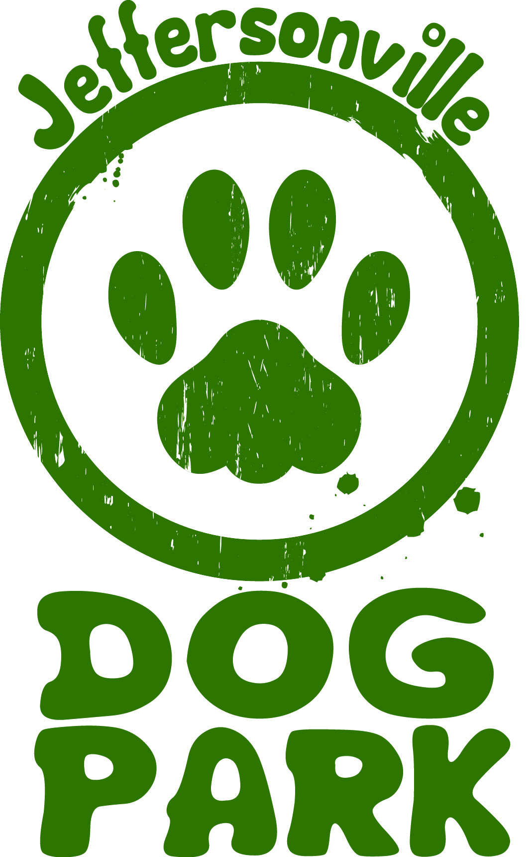
Jeffersonville Parks & Recreation Department
500 Quartermaster Court, Suite 205
DOG PARK MEMBERSHIP APPLICATION
Allows key FOB access to Jeffersonville Highland Dog Park at 1300 Spruce Drive
All dogs must be registered at the same owner residence

Owner name(s) ___________________________ Vet/Clinic______________________________
________________________________________ Phone number__________________________
Address__________________________________ OFFICE USE:
City_____________________________________ Receipt # ______________________________
State _________________ Zip_______________ Key Fob # ______________________________
Cell number______________________________ *Date of registration_____________________
E-mail __________________________________ *EXPIRES in 1 yr. (or if immunizations are due)

Dog ID Info All dogs must be spayed/neutered and at least 4 months of age
Name
Breed
Weight
Color
DOB

After dog park registration & payment send up to date immunization record(s) to: ParksInfo@cityofjeff.net
List date Immunization Expires *must provide documentation from Vet of expiration dates
Rabies
Distemper
Parvo
Bordetella/ Kennel Cough

